**Invoice Processing Project Document**



**Session: 2021**

**Submitted by:**

**Muhammad Labeeb Tariq** **2021-SE-15**

**Numan Ahmad**  **2021-SE-24**

**Wali Muhammad** **Ahmad 2021-SE-39**

**Submitted to:**

**Dr. Qurat-ul-Ain**

Department of Computer Science,

**University of Engineering and Technology, New Campus Lahore**

**Computer Vision Invoice Processing Project**

### **Project Overview**

This manual outlines the step-by-step process for developing a computer vision-based invoice processing system as part of the Computer Vision and Image Processing (CVIP) semester project. The system is designed to read invoice images, extract and process data, store it in a database, and provide analytical insights such as total sales tax by year, invoice summaries, and data views based on specified durations.

### **Folder Structure**

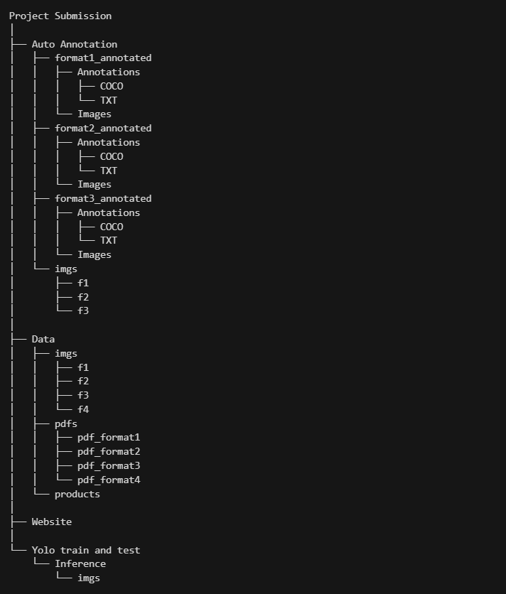

### **Initial Setup**

#### **Provided Data**

1. **Supplier Data (supplier.xlsx)**
   1. **Columns:**
      1. Receipt_NO
      2. NTN
      3. NAME
      4. BUSINESS_NAME
      5. S.T.Reg. No
      6. Phone Number
      7. Address
2. **Customer Data (customer.xlsx)**
   1. **Columns:**
      1. NTN
      2. NAME
      3. S.T.Reg. No
      4. Address

### **Step 1: Extract Business Names**

1. **Objective:** Extract business names from the supplier data and save them in a text file for further processing.
2. **Procedure:**
   1. Write a Python script to read supplier.xlsx.
   2. Extract the "BUSINESS_NAME" column.
   3. Save the unique business names into a text file named business.txt.

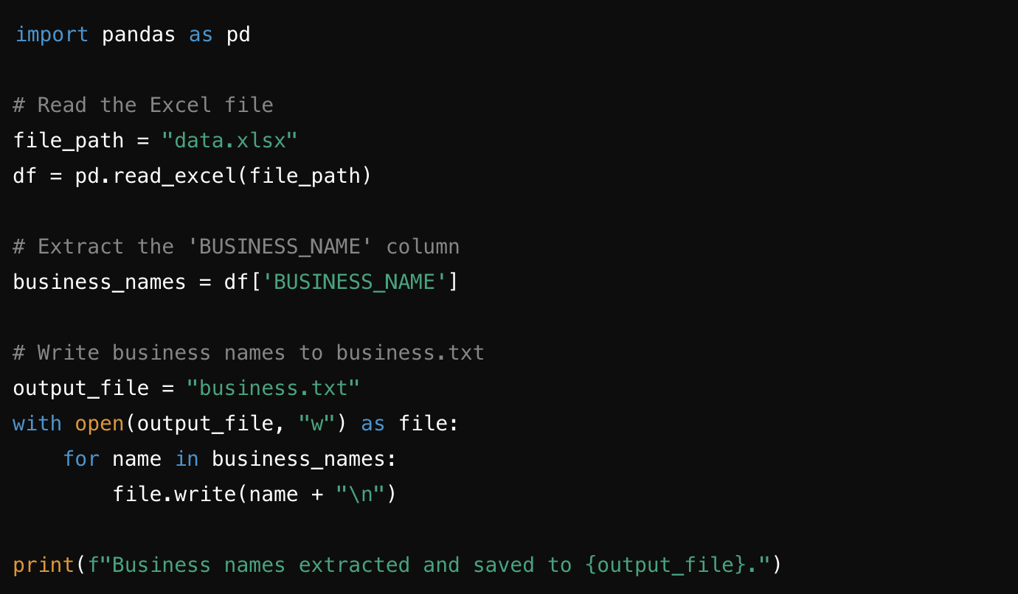

### **Step 2: Generate Product Names Using EXOME LLM**

1. **Objective:** Generate potential product names for each business.
2. **Procedure:**
   1. Create a file named business.txt containing the extracted business names.
   2. Use a notebook that integrates EXOME LLM to:
      1. Read business.txt.
      2. Generate four potential product names for each business.
      3. Save the output in an Excel file named products_business.xlsx with the following structure:
         1. **Columns:** Business Name, Product 1, Product 2, Product 3, Product 4

### Code:

#### Initial setup:

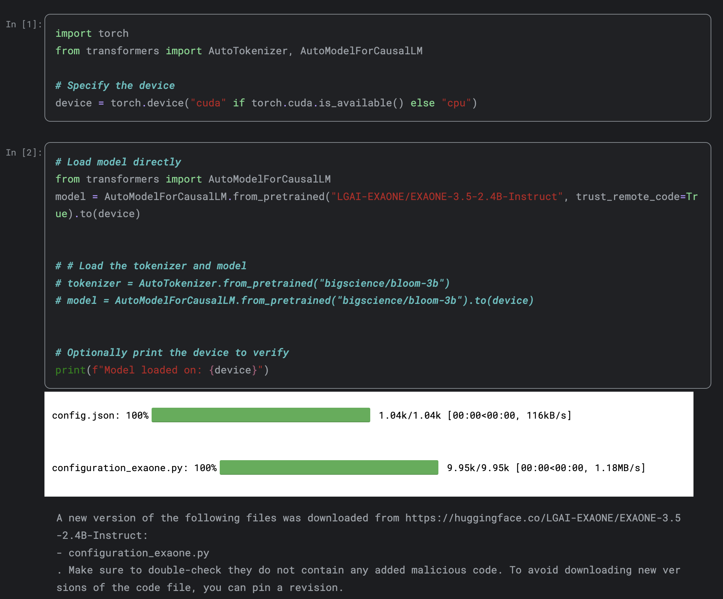

#### Read input files and define output directory:

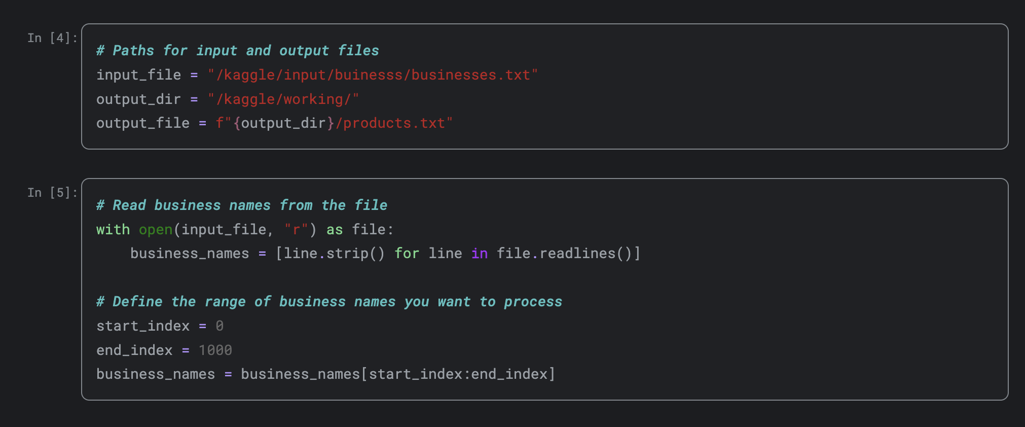

#### Function with prompt to generate products:

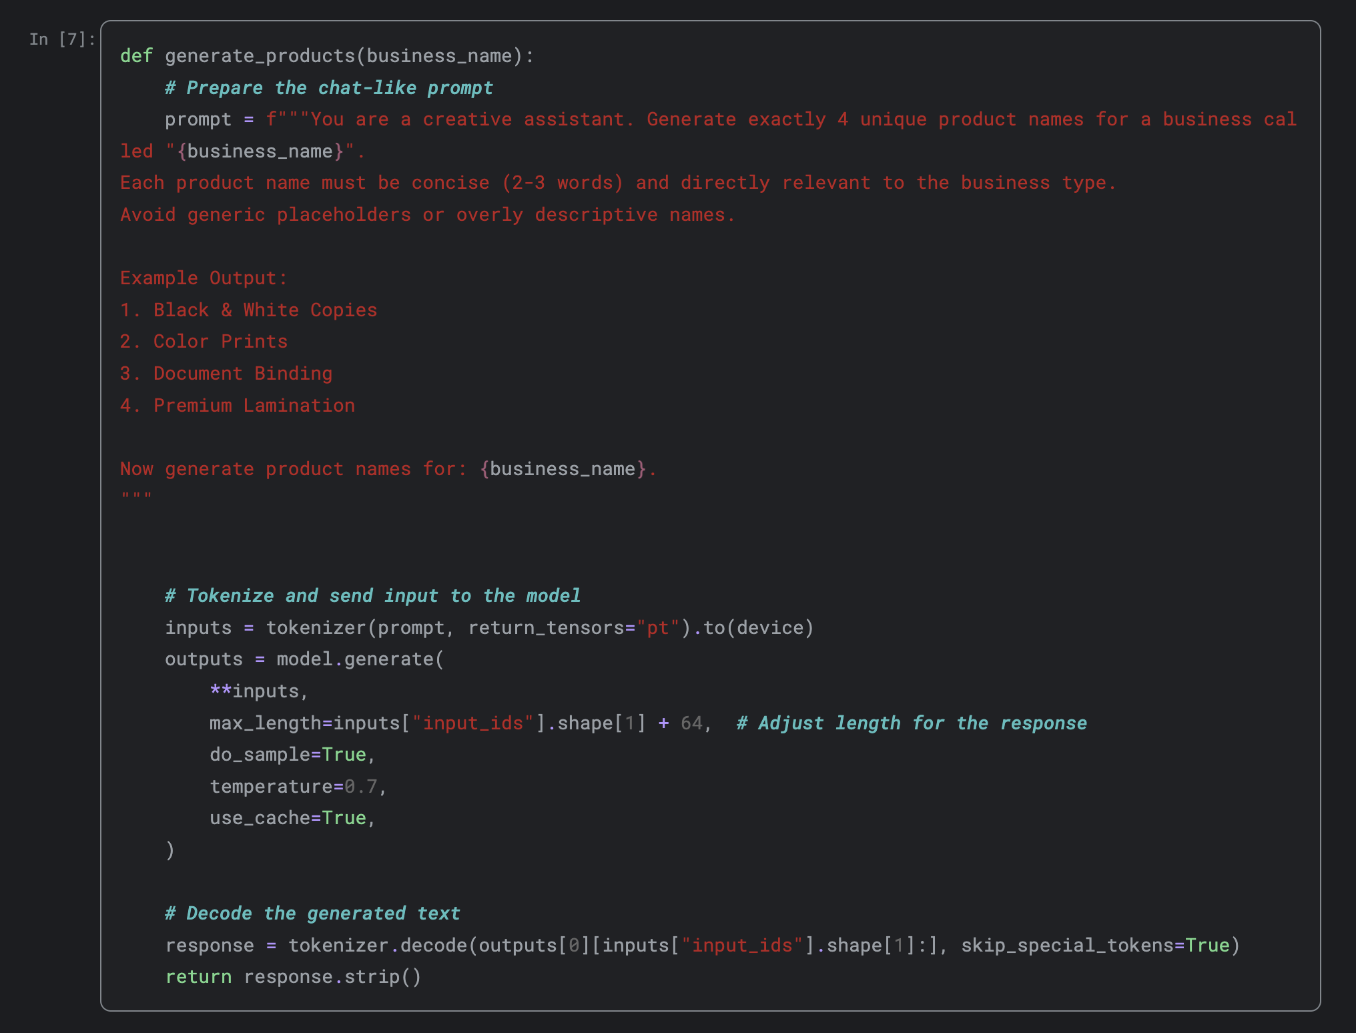

#### Extract products names from response:

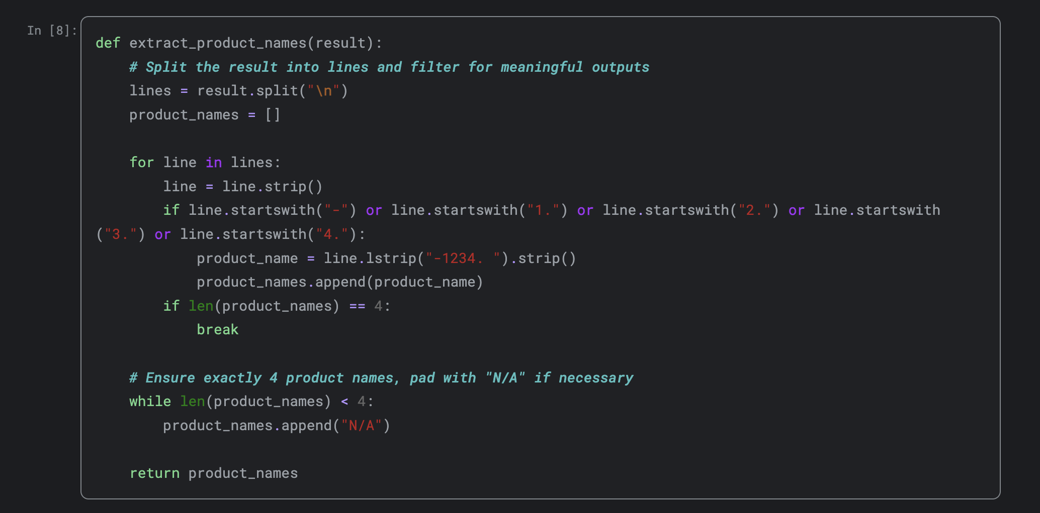

#### Run model and generate file:

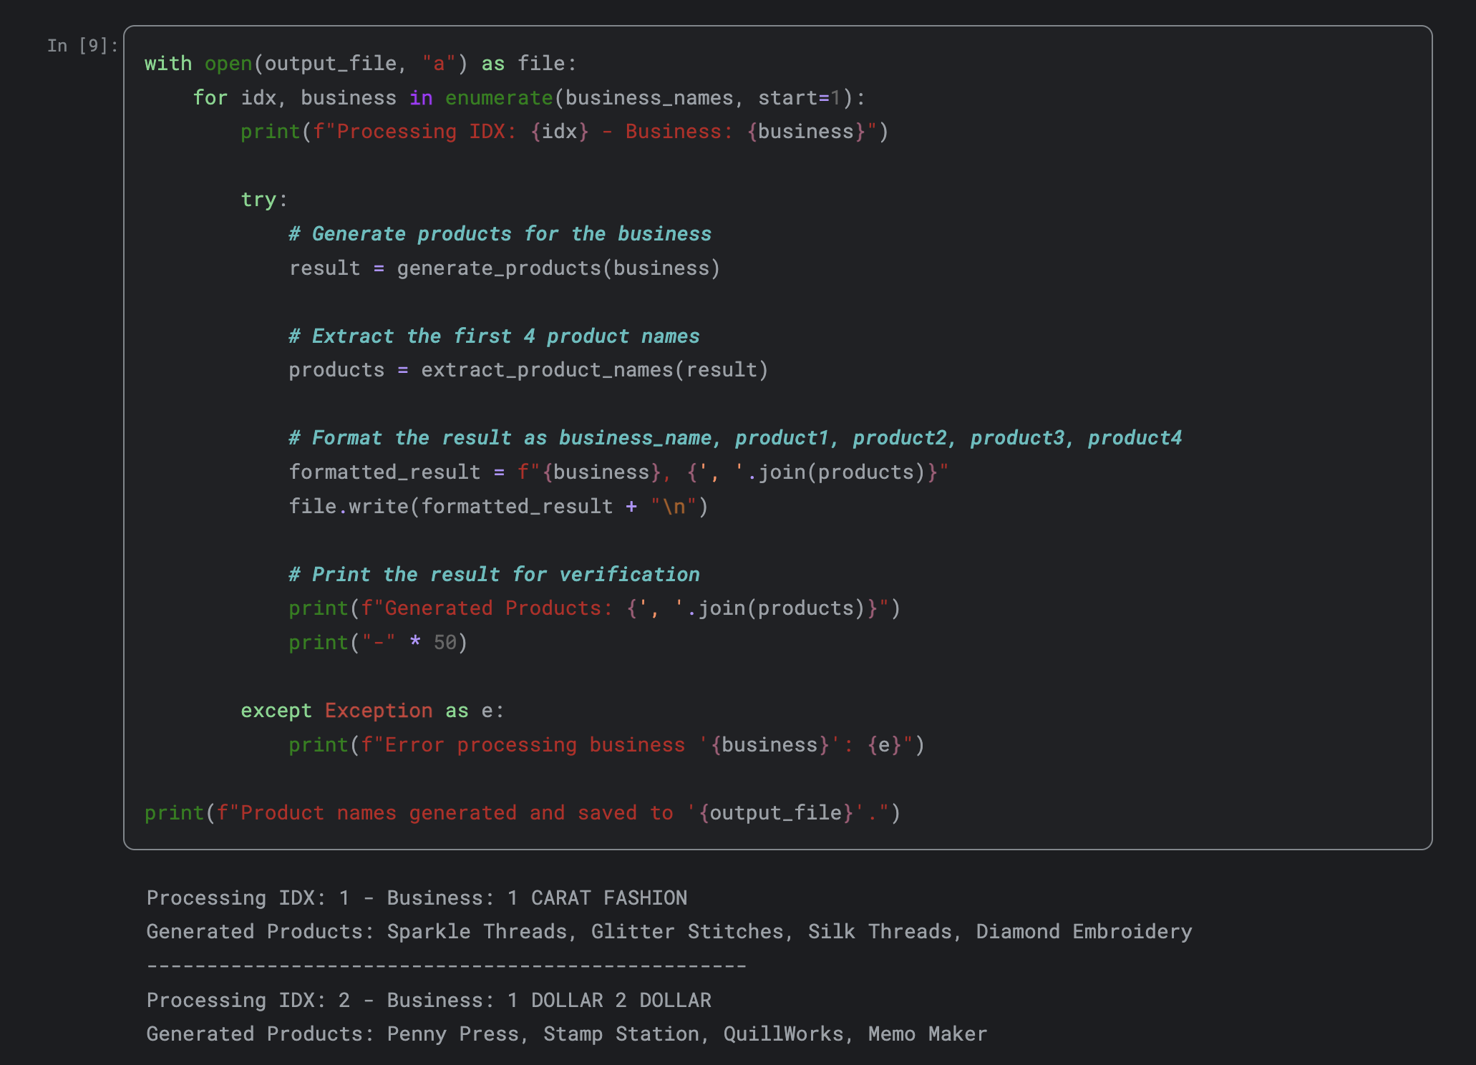

#### Output File:



### **Step 3: Data Preparation for Invoice Generation**

1. **Objective:** Combine customer, supplier, and product data to generate invoice records.
2. **Procedure:**
   1. Merge data from customer.xlsx, supplier.xlsx, and products_business.xlsx.
   2. Generate dates ranging from 2019 to 2024.
   3. Create a consolidated file with 20,000 invoice records.
3. **Invoice Data Structure:**
   1. Columns include customer details, supplier details, products, quantities, and dates.

#### Combine all xlsx files:

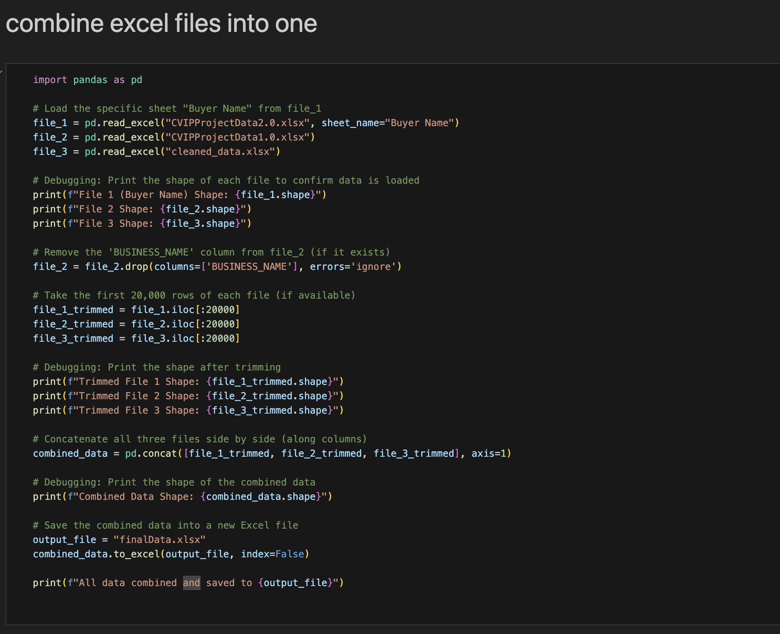

#### Adding calculations according to Data:

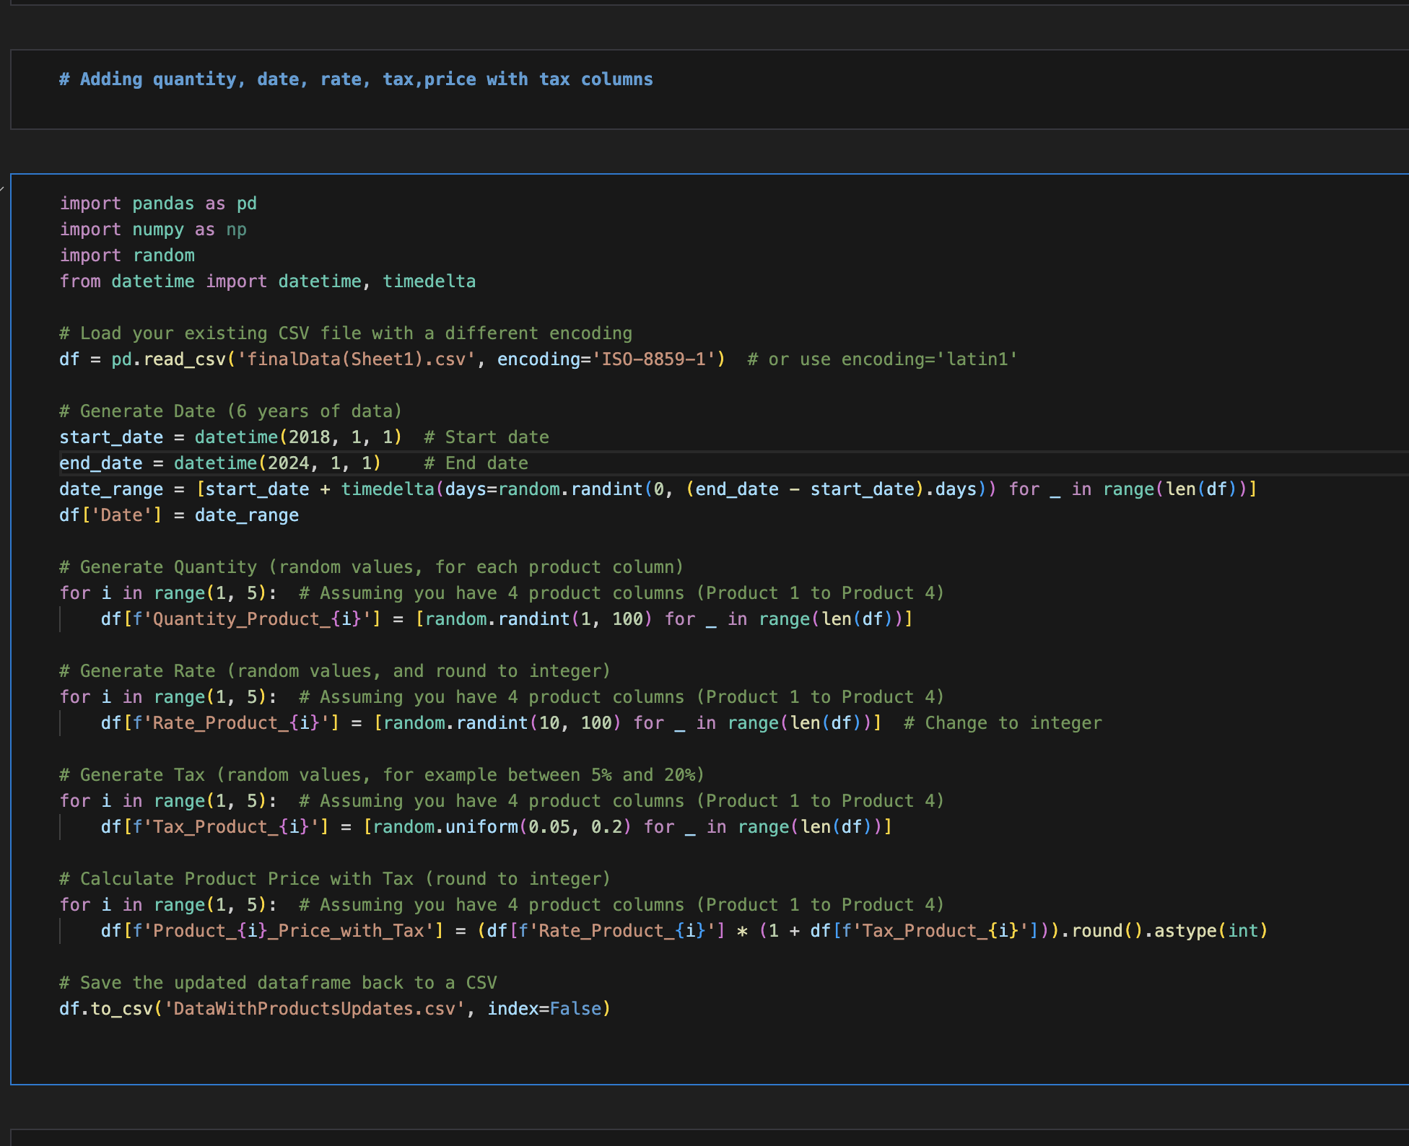

#### Adding Date in file:

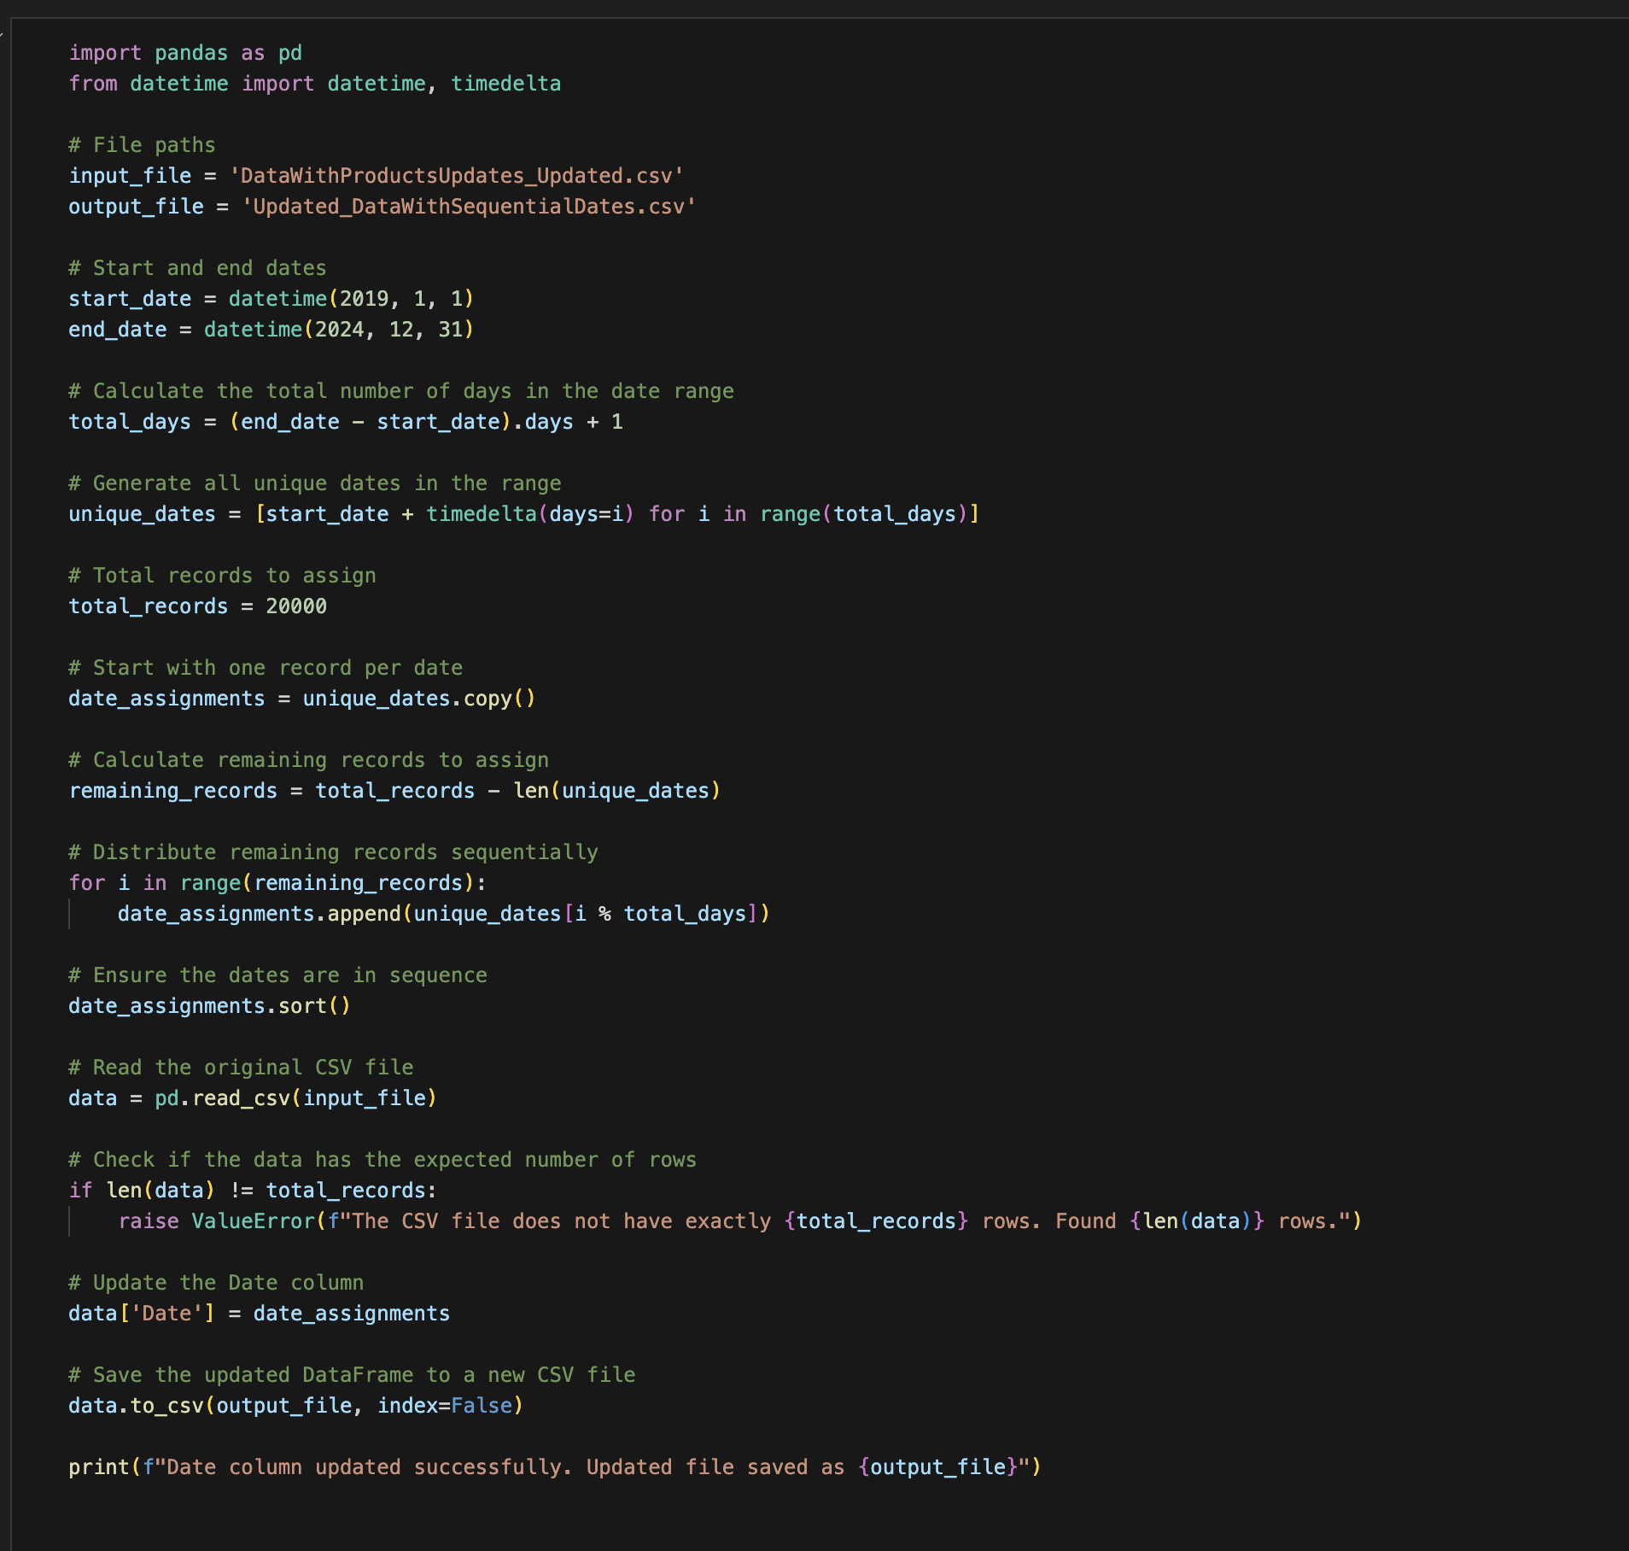

### **Step 4: Generate Invoice PDFs and Images**

1. **Objective:** Create PDF and image formats of invoices for model training.
2. **Procedure:**
   1. Generate invoices in four different formats for diversity.
   2. Use 5,000 records for each format.
   3. Convert the generated PDFs into images.

### **Step 5: Data Annotation Using Roboflow**

1. **Objective:** Annotate sample invoice images to train the YOLO v11 model.
2. **Procedure:**
   1. Use Roboflow to annotate a sample of invoice images.
   2. Export annotations in COCO and YOLO formats.

#### Sample Data anootated using roboflow:

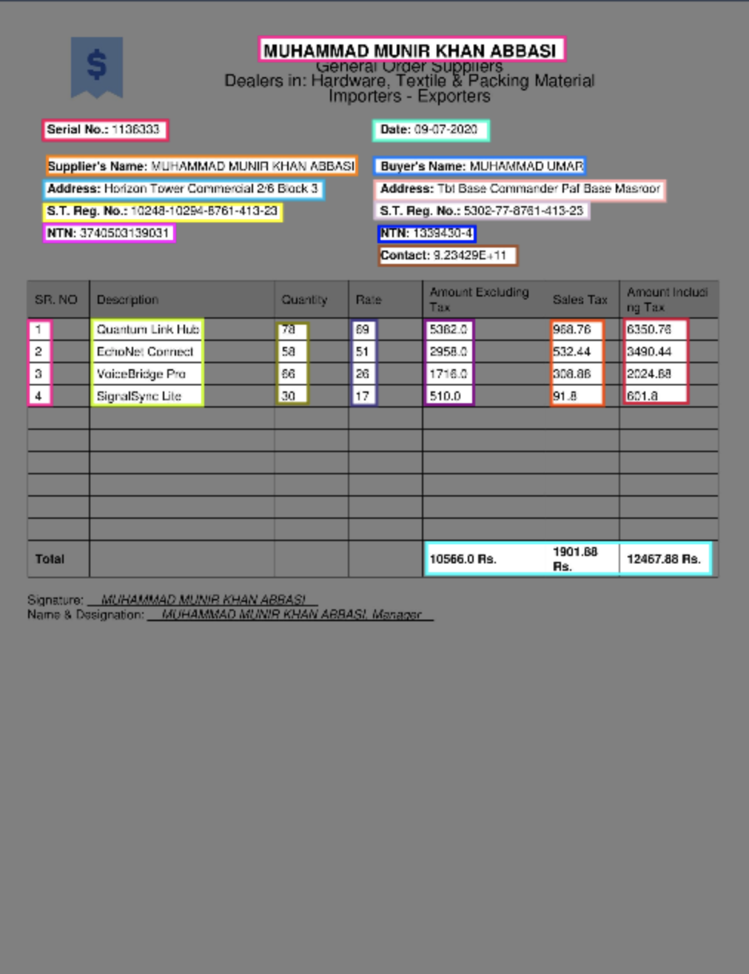

### **Step 6: Train YOLO v11 Model**

1. **Objective:** Train the YOLO v11 model to detect and annotate key fields in invoice images.
2. **Procedure:**
   1. Use the annotated data from Roboflow to train the YOLO v11 model.
   2. Generate YOLO training text files.

#### Initial setup:

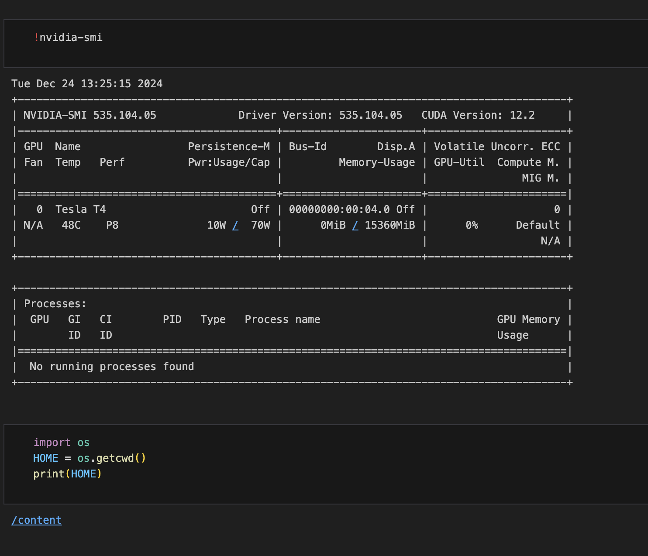

#### Importing data and pretrained yolov11 model:

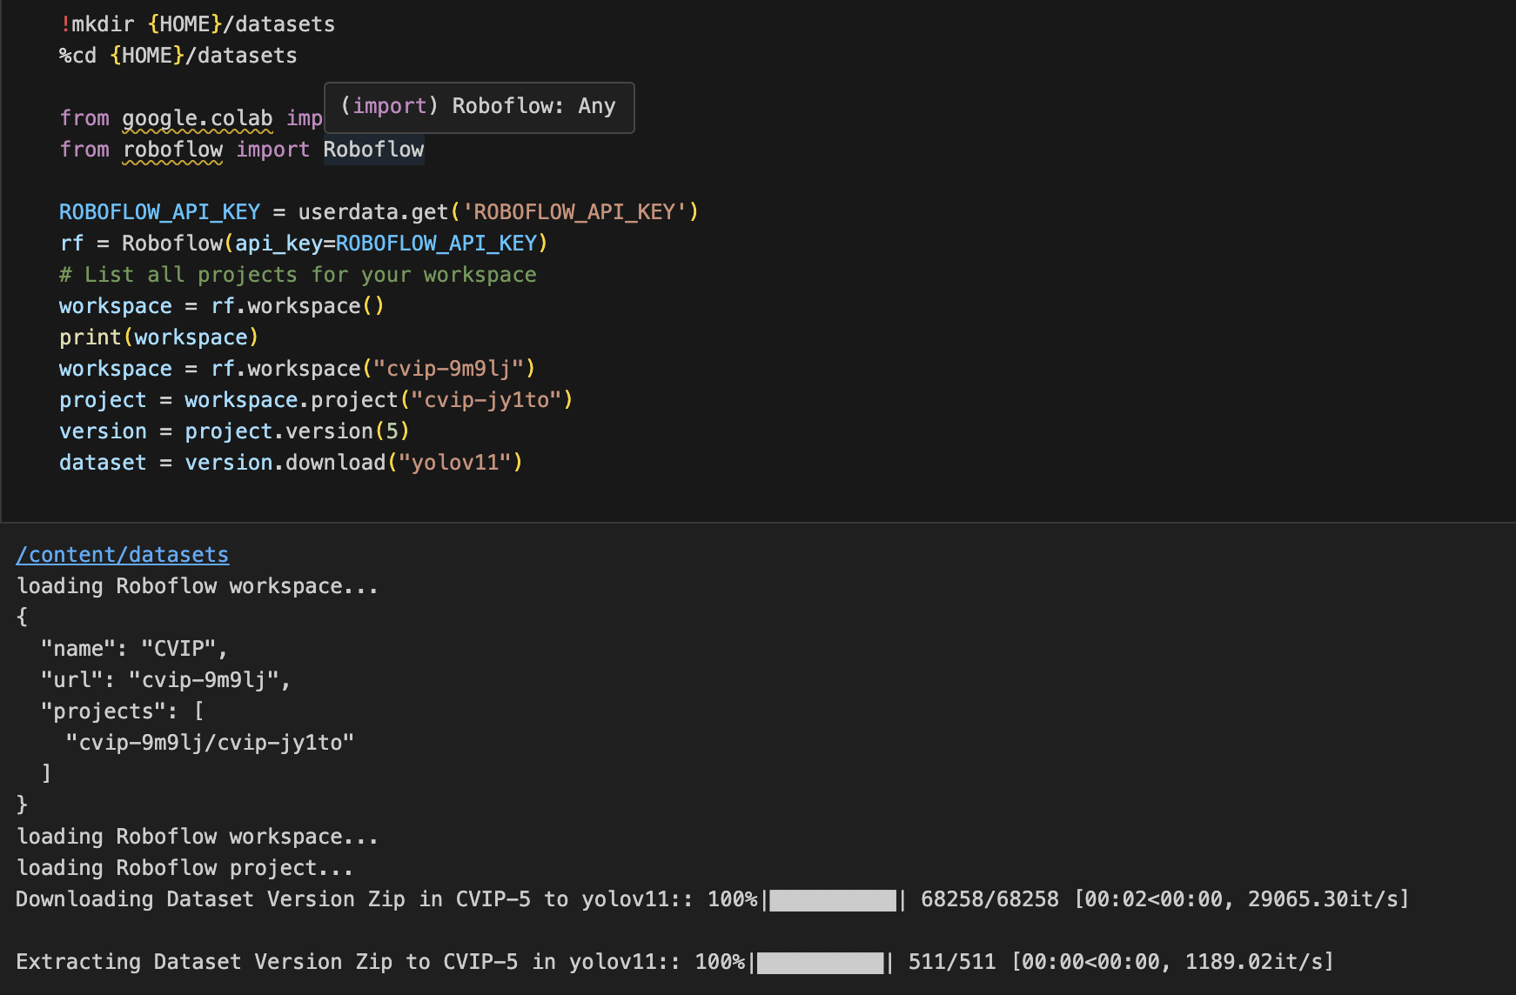

#### Training:

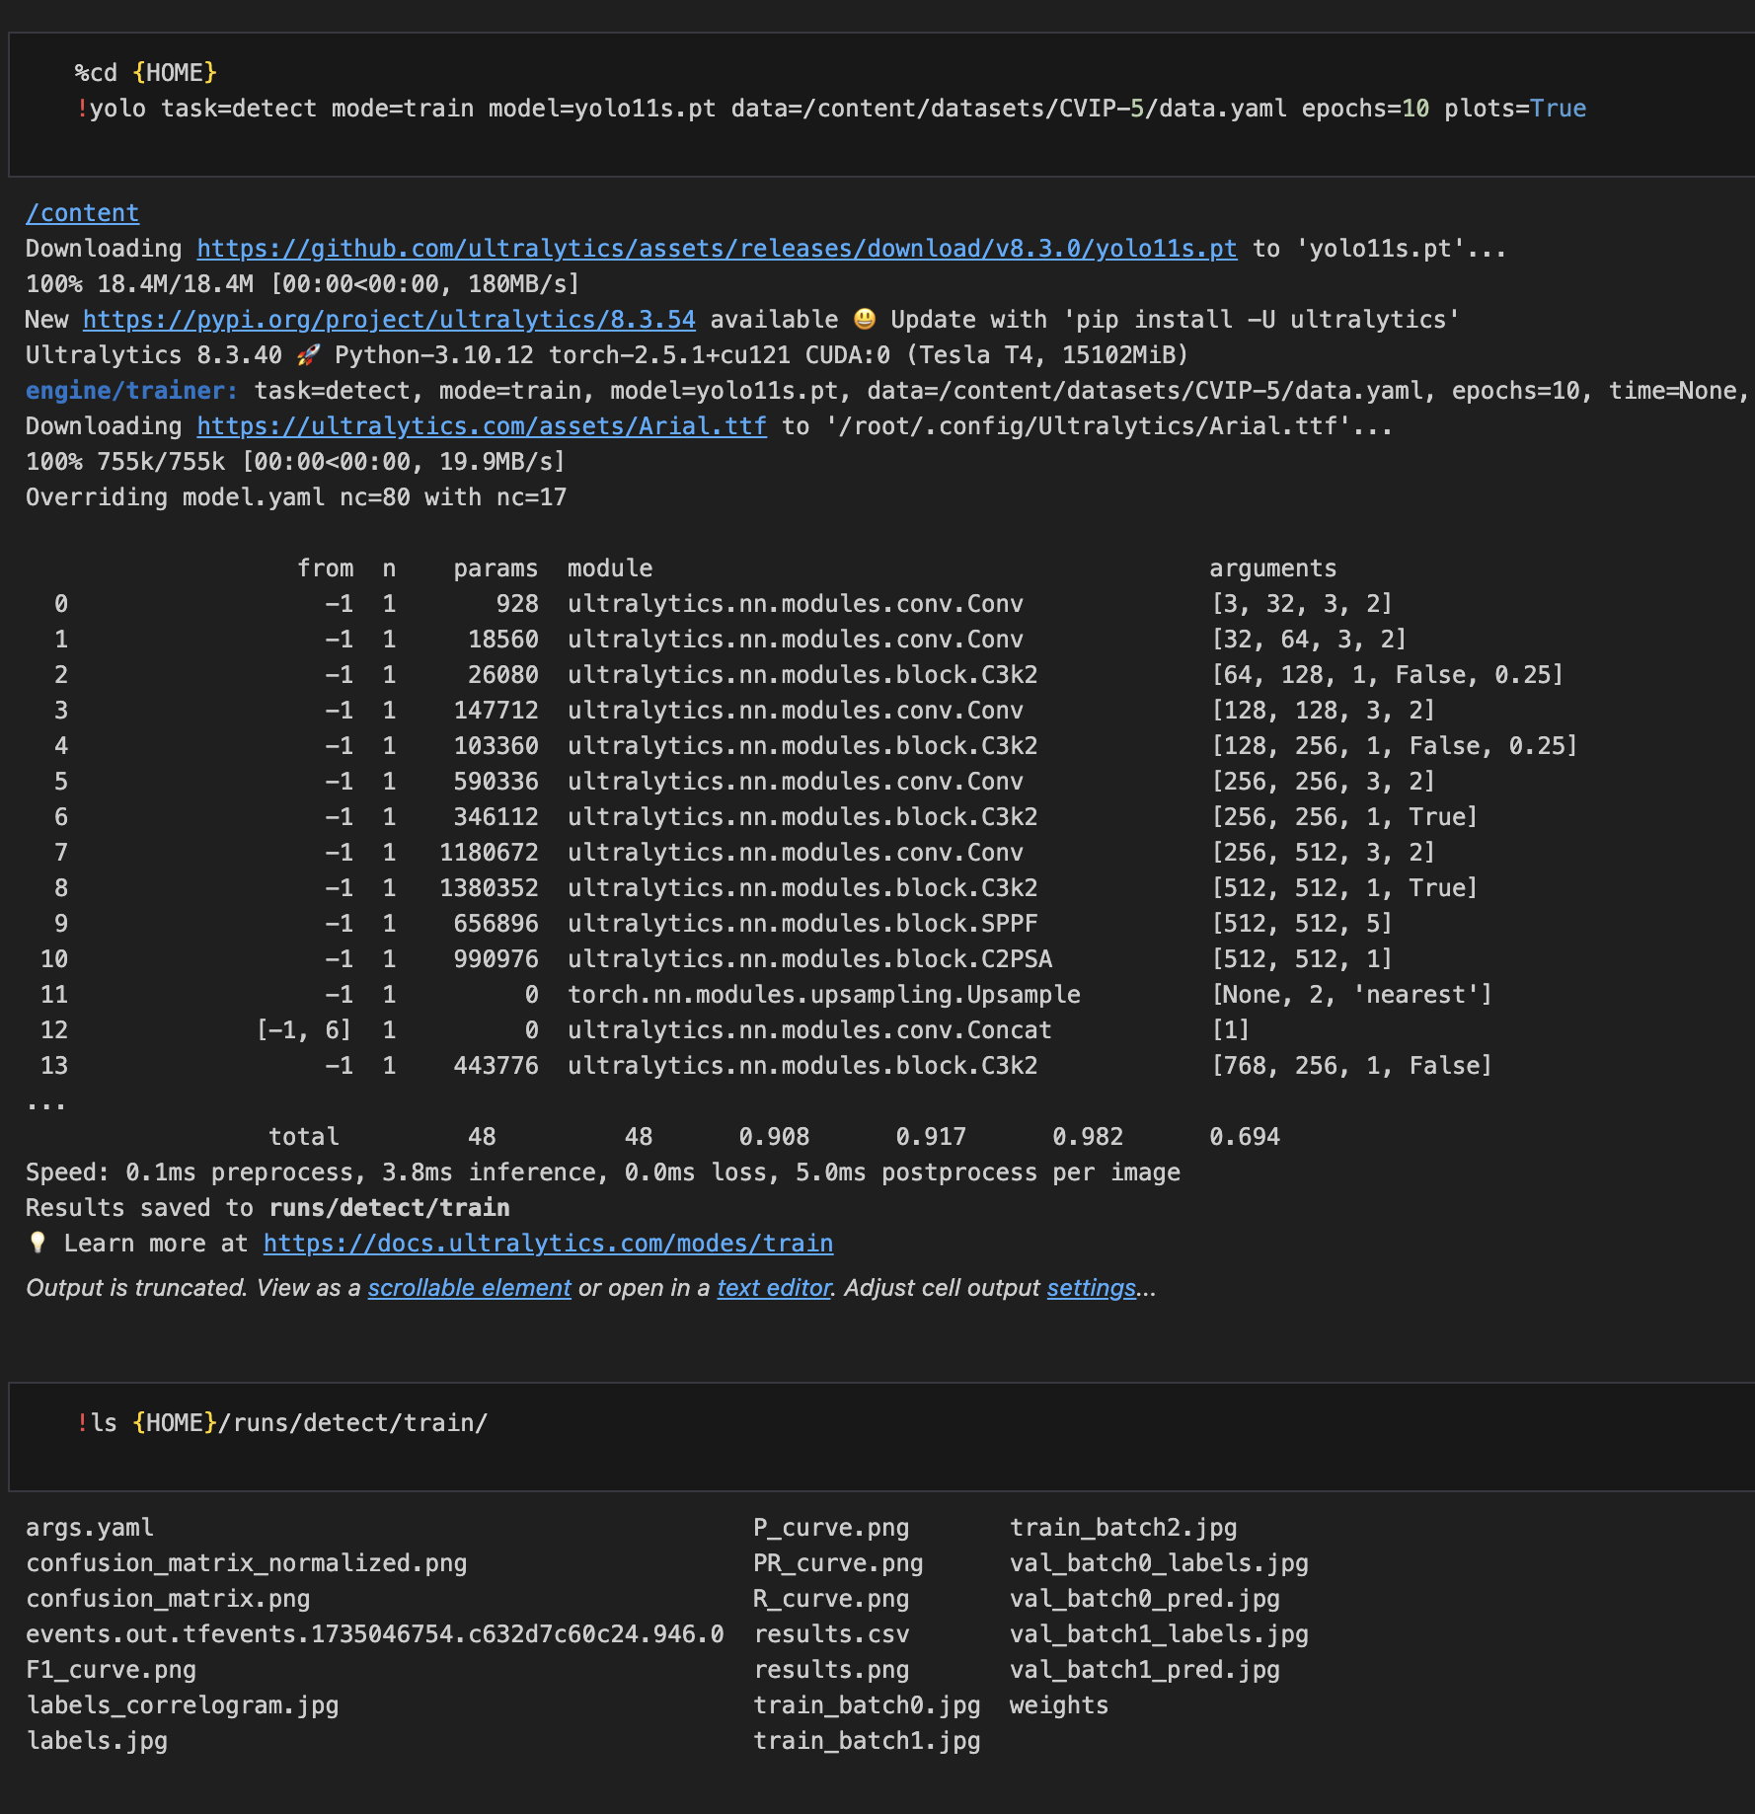

#### *Confusion matrix of training:*

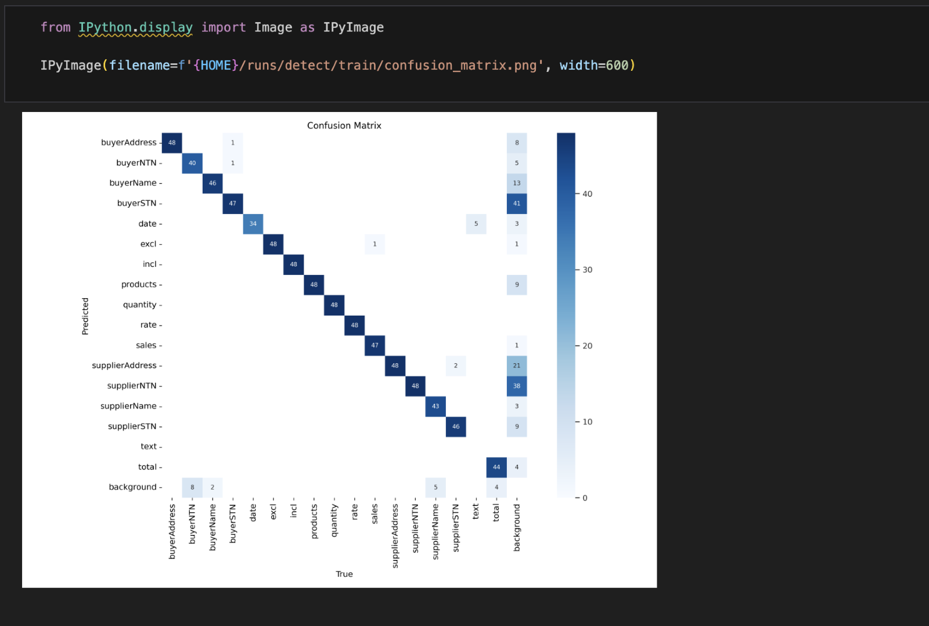

#### *Training results:*

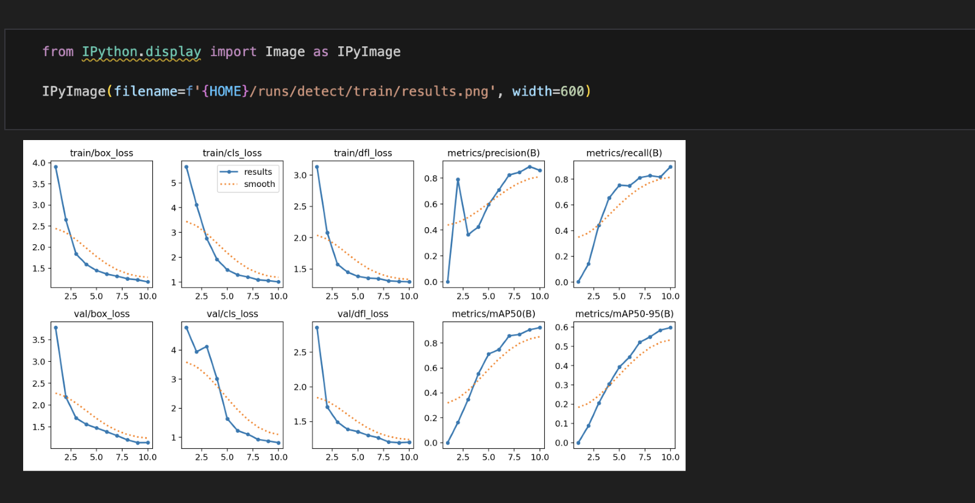

#### *Validations:*

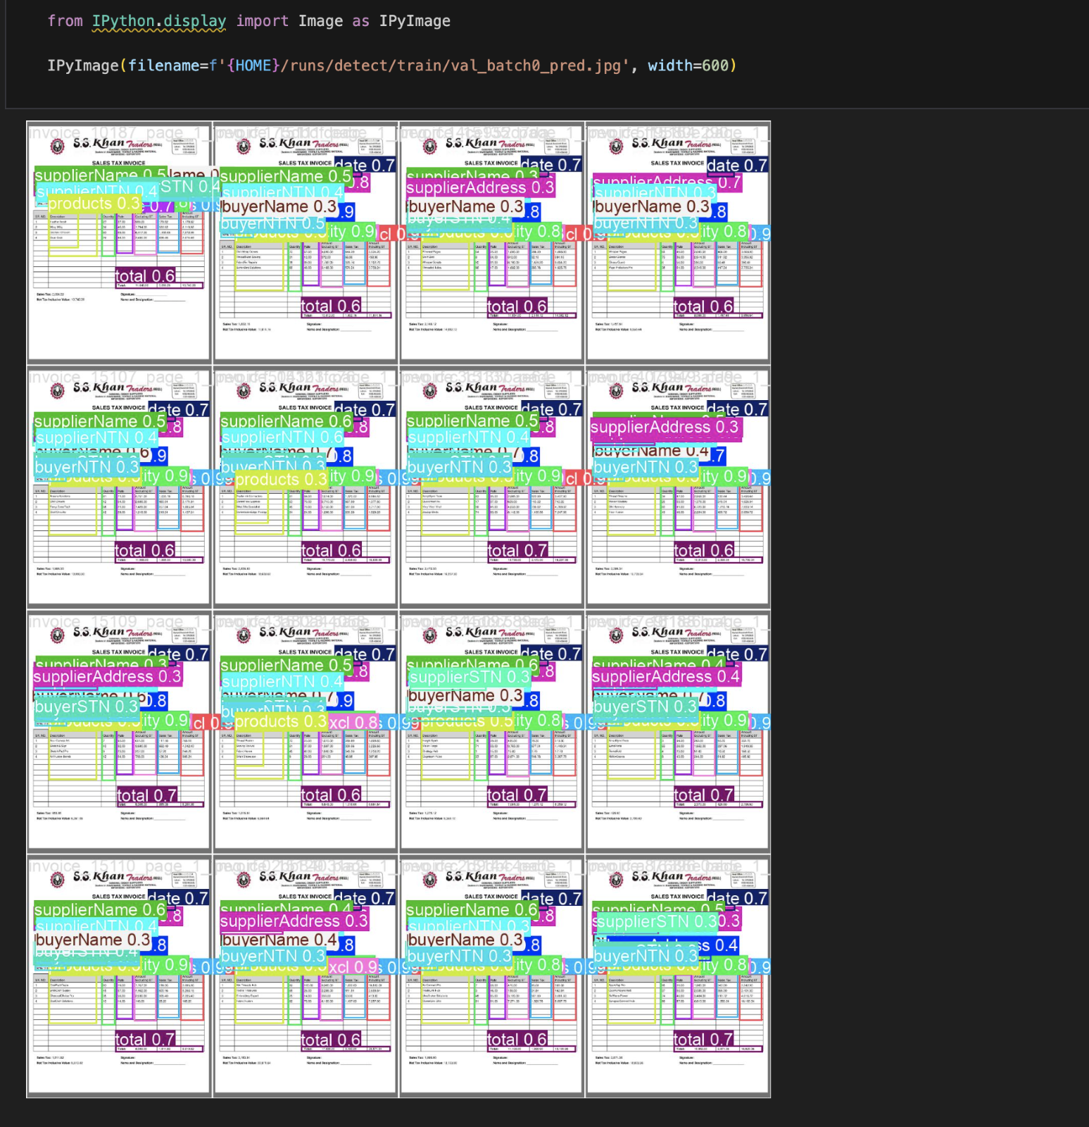

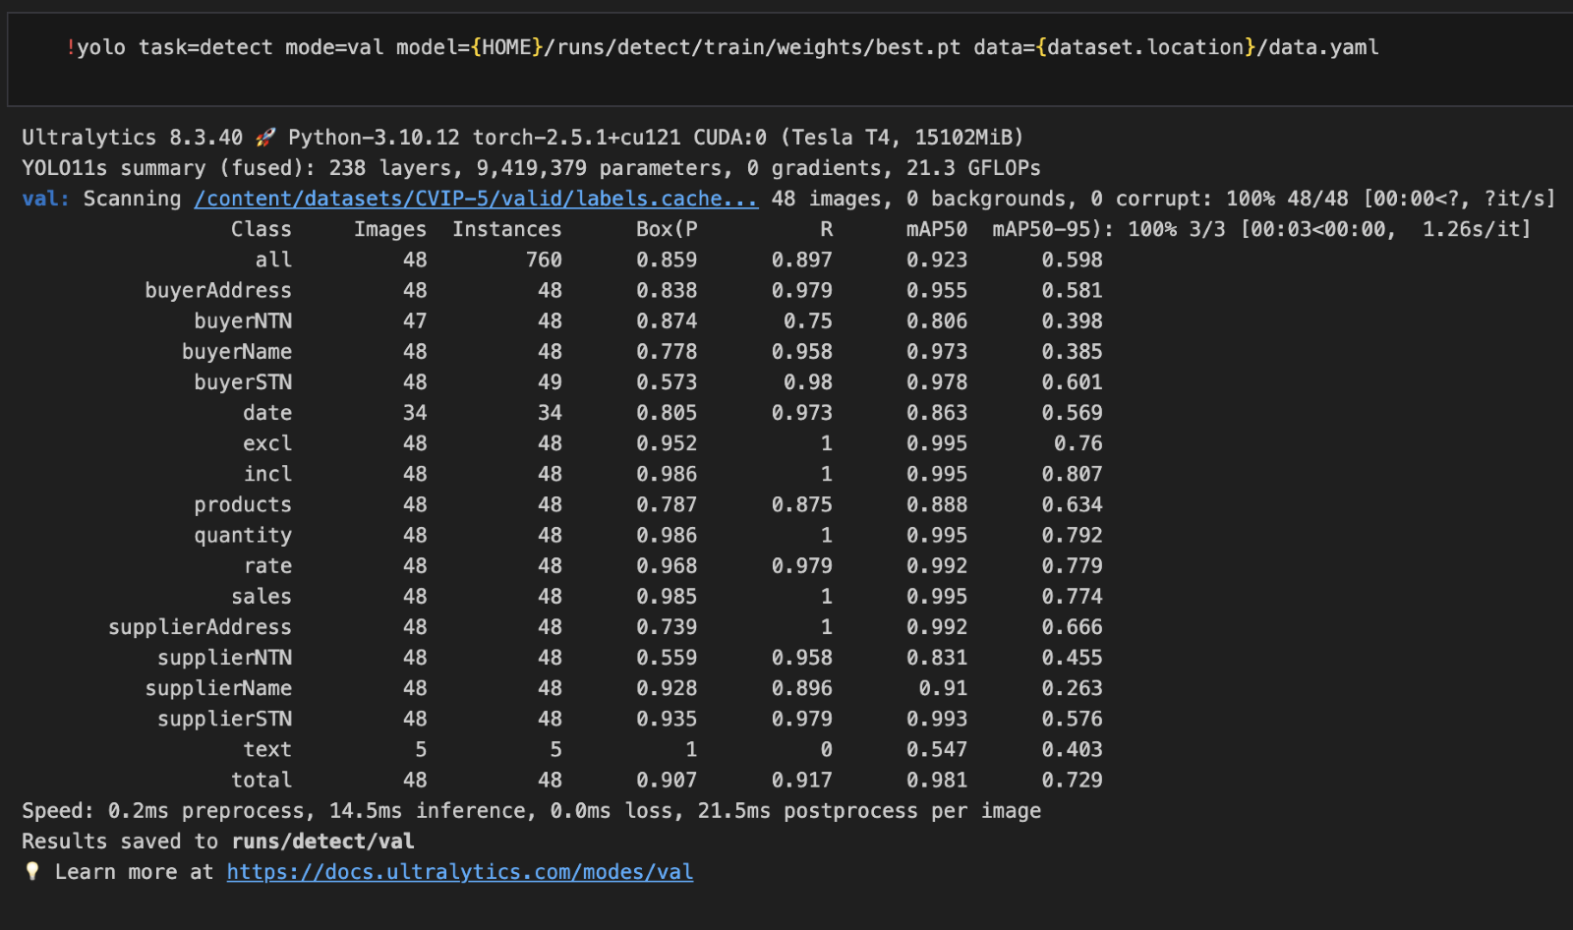

#### *Testing:*

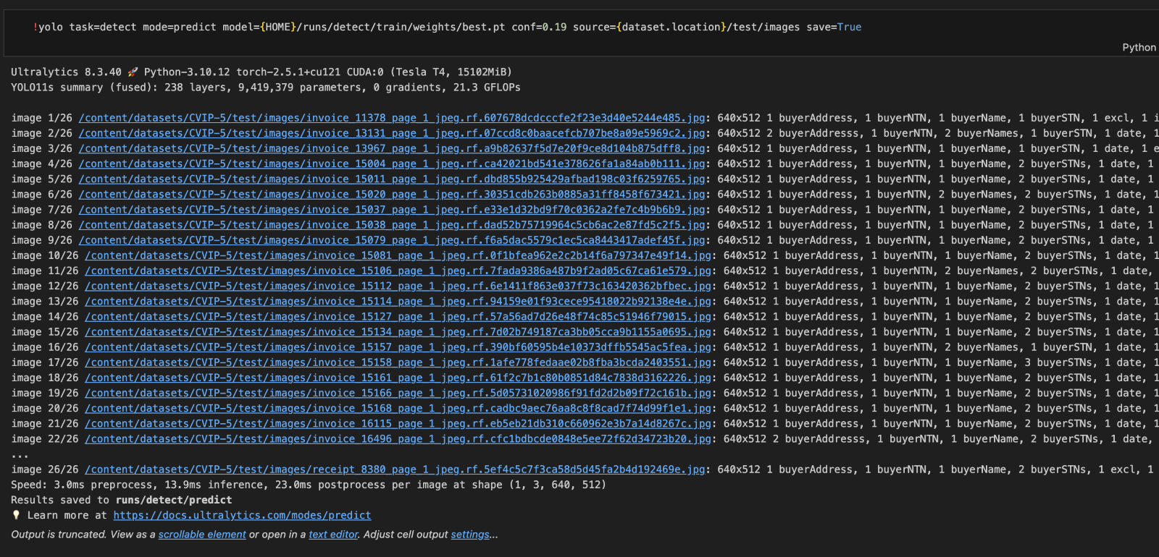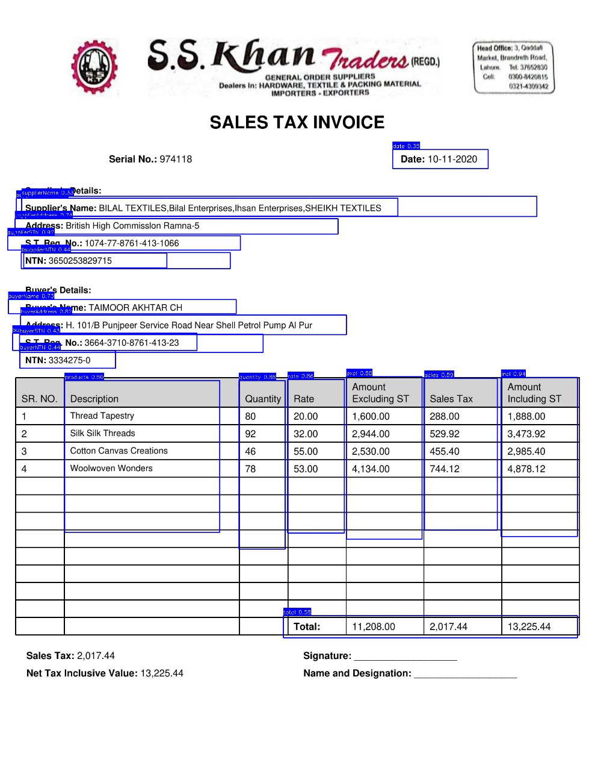

### **Step 7: Data Extraction Using Tesseract**

1. **Objective:** Extract annotated data from invoice images.
2. **Procedure:**
   1. Use Tesseract OCR to extract text data from the annotated images.
   2. Clean and structure the extracted data.

### **Step 8: Data Storage and Analysis**

1. **Objective:** Store extracted data in SQLite and provide analytical insights.
2. **Procedure:**
   1. Create an SQLite database to store the cleaned data.
   2. Implement queries for:
      1. Total sales tax by year.
      2. Summary of invoices.
      3. Data views based on specified durations.

### **Step 9: Web Application Development**

1. **Objective:** Develop a user-friendly interface to interact with the system.
2. **Procedure:**
   1. **Backend:**
      1. Use Flask to create APIs for data storage, retrieval, and analysis.
   2. **Frontend:**
      1. Use HTML and CSS to design the user interface.

### **Conclusion**

This manual provides a detailed guide for replicating the invoice processing system. The system combines state-of-the-art machine learning techniques with robust backend development to deliver a comprehensive solution for invoice management and analysis.